Freeform Closed Curved Shapes
# Source: AI Source: Provided by: [Data Path: Persons Table -> ID Column: 1, Name_En Column: Motasem Essam] -> From: [ChatGPT] on [7/25/2026]
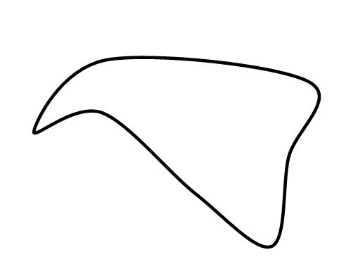
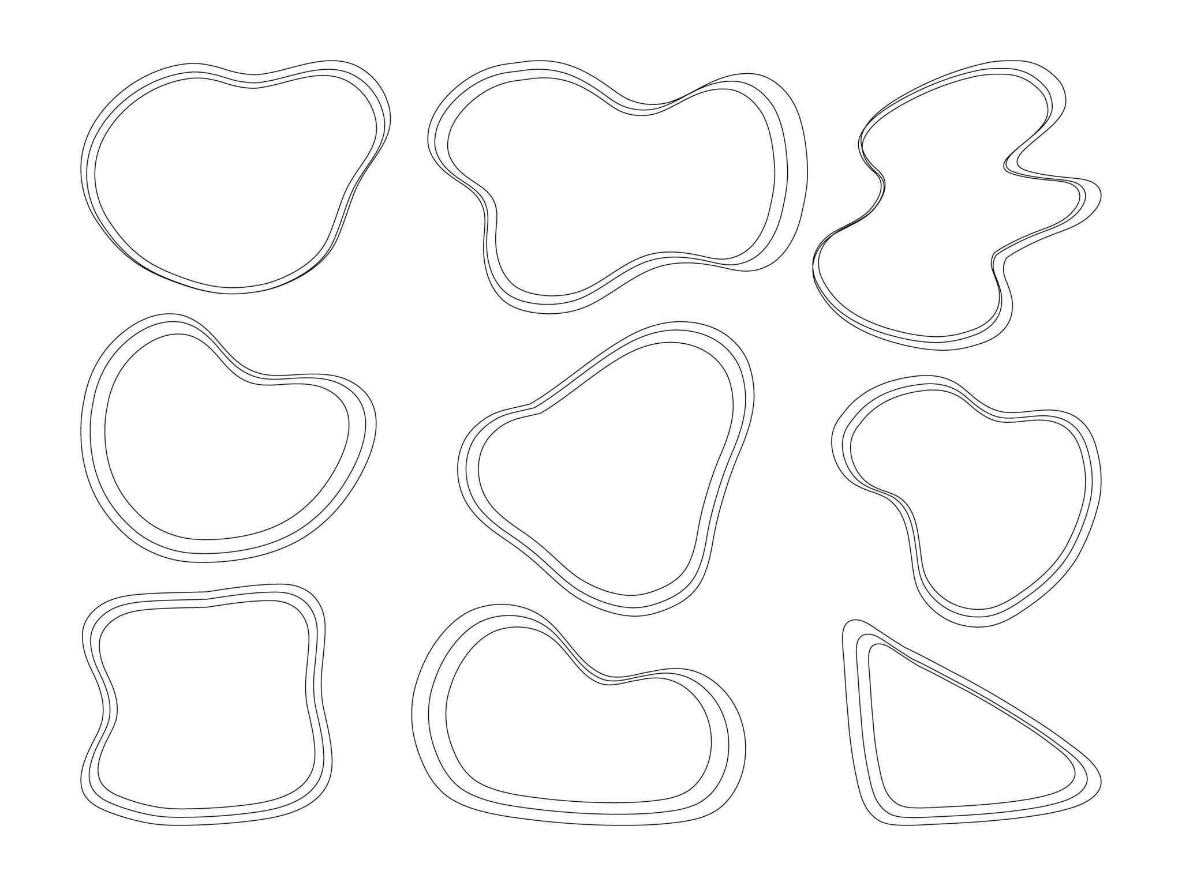
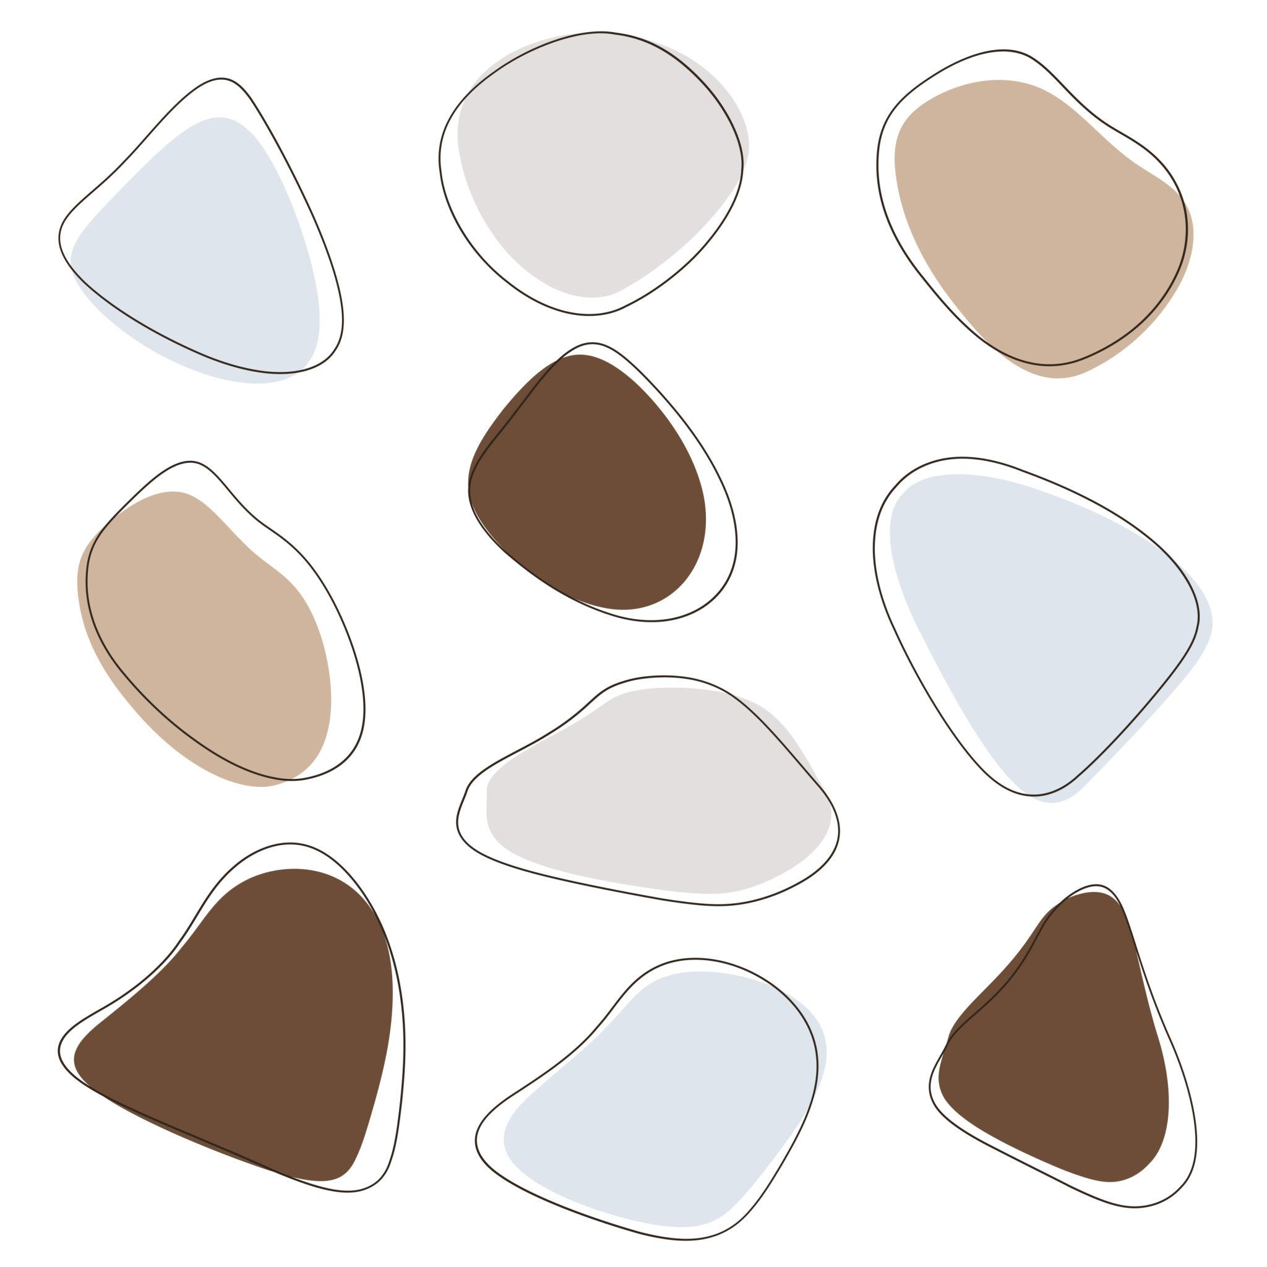
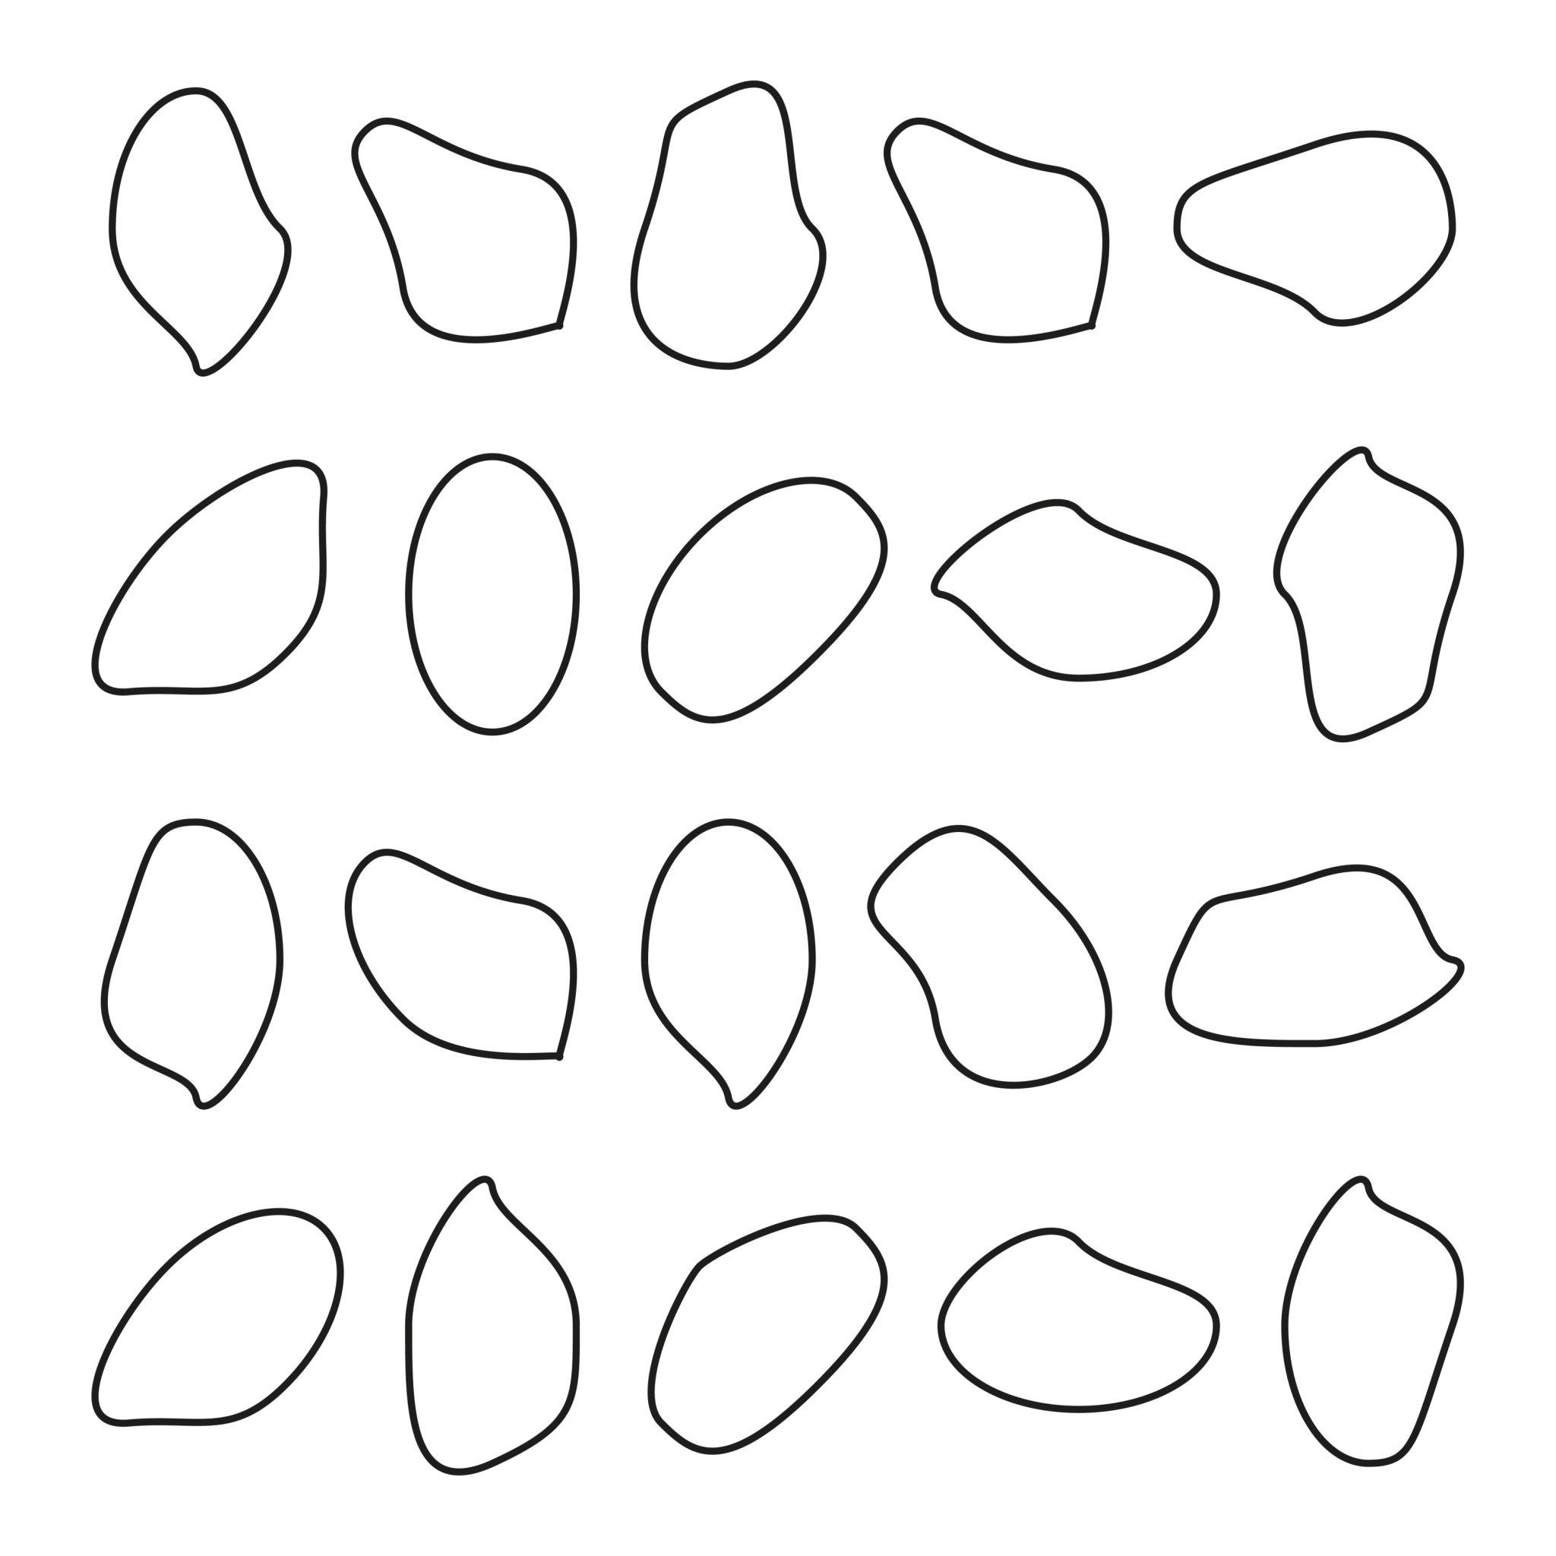
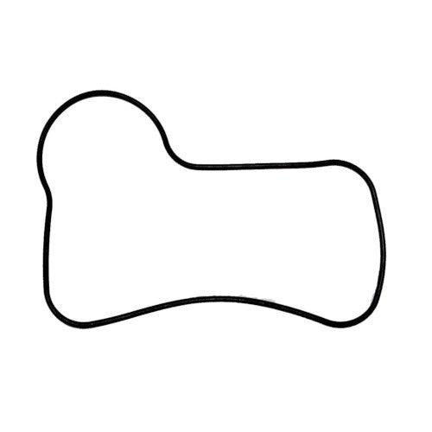
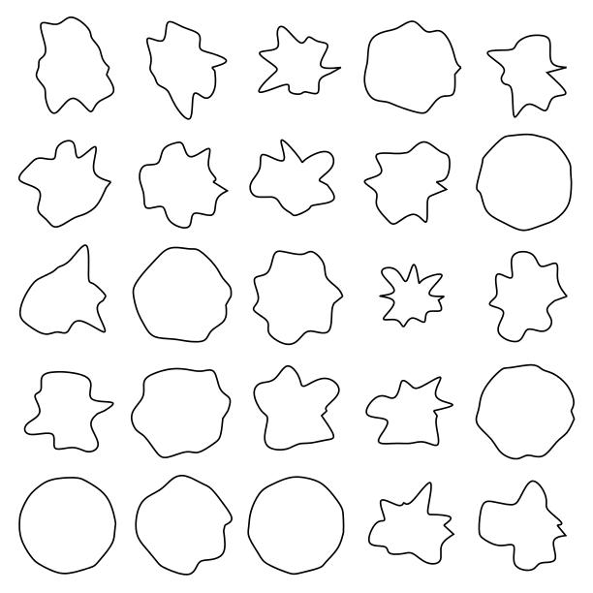

Definition
# Source: AI Source: Provided by: [Data Path: Persons Table -> ID Column: 1, Name_En Column: Motasem Essam] -> From: [ChatGPT] on [7/25/2026]
A Freeform Closed Curved Shape is a closed curved shape whose boundary is freely designed or controlled rather than being restricted to a standard geometric curve such as a circle or ellipse.
Its boundary can have continuously varying curvature, and its exact form may be created manually, artistically, or using mathematical spline/Bezier representations.
$$\boxed{\text{Freeform Closed Curved Shape}=\text{Closed}+\text{Curved}+\text{Freely Designed}}$$

Characteristics
# Source: AI Source: Provided by: [Data Path: Persons Table -> ID Column: 1, Name_En Column: Motasem Essam] -> From: [ChatGPT] on [7/25/2026]
A freeform closed curved shape typically:
- Is closed.
- Has a continuous curved boundary.
- Has no open endpoints.
- Encloses a bounded region.
- Has no required standard geometric equation.
- May have continuously changing curvature.
- May be symmetric or asymmetric.
- May be regular-looking or highly irregular.
- Can be created using Bézier curves, splines, or other freeform methods.
The defining closed condition is:
$$\boxed{P_{\text{start}}=P_{\text{end}}}$$

Types of Freeform Closed Curved Shapes

1. Bézier Closed Curves
# Source: AI Source: Provided by: [Data Path: Persons Table -> ID Column: 1, Name_En Column: Motasem Essam] -> From: [ChatGPT] on [7/25/2026]
A Bézier closed curve is constructed from Bézier curve segments whose endpoints are connected to form a closed boundary.
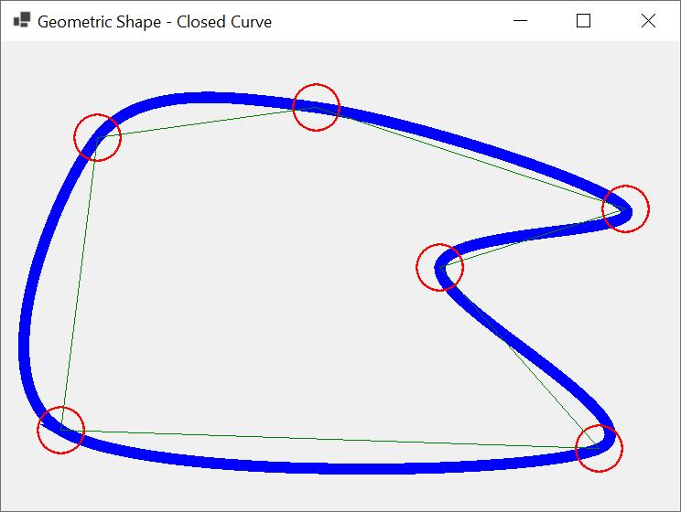
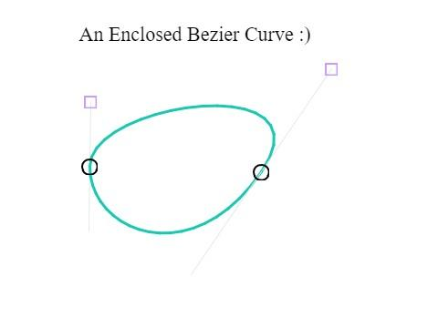
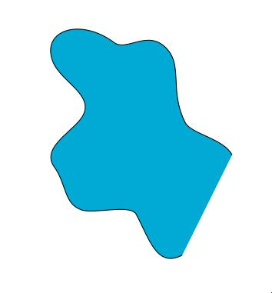
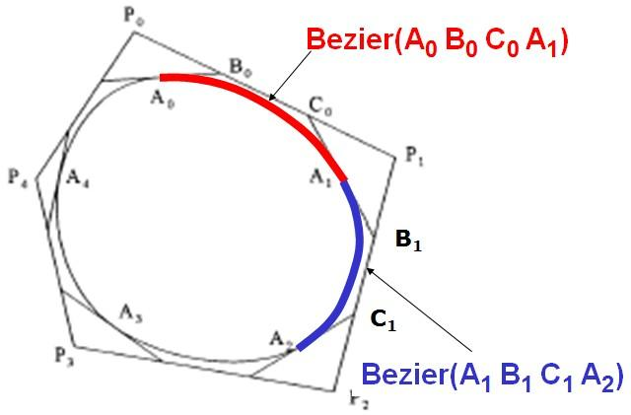
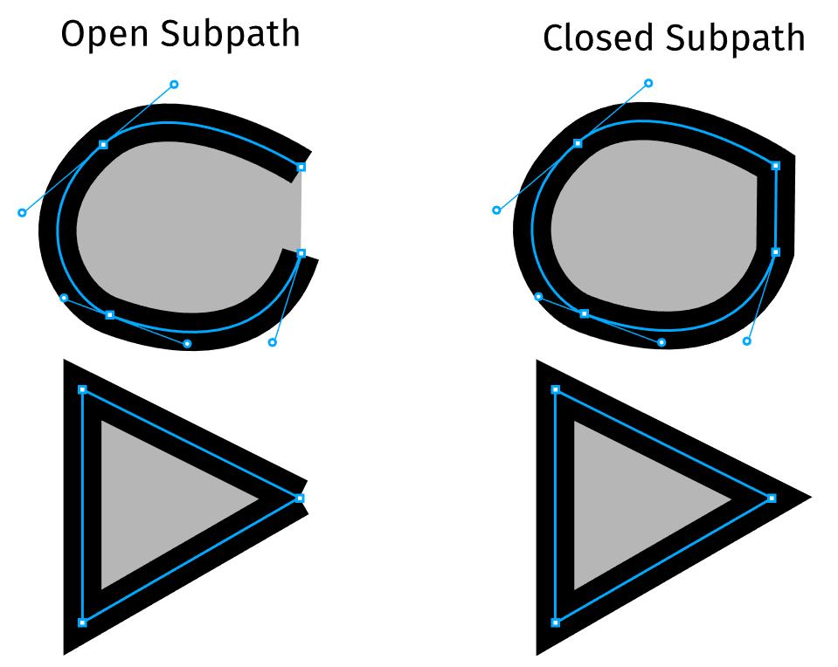
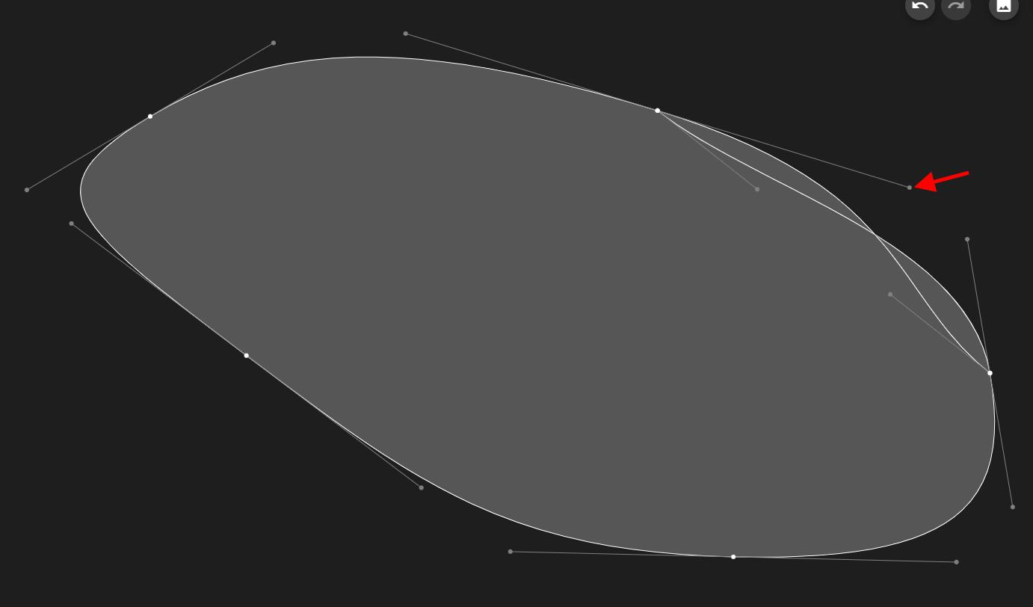
A cubic Bézier segment can be represented as:
$$\boxed{B\left(t\right)={\left(1-t\right)}^{3}P_{0}+3{\left(1-t\right)}^{2}tP_{1}+3\left(1-t\right)t^{2}P_{2}+t^{3}P_{3}}$$
with:
$$0≤t≤1$$
Multiple Bézier segments can be joined to create a closed freeform shape.

2. Spline-Based Closed Curves
# Source: AI Source: Provided by: [Data Path: Persons Table -> ID Column: 1, Name_En Column: Motasem Essam] -> From: [ChatGPT] on [7/25/2026]
A spline-based closed curve is created by smoothly connecting multiple control points.
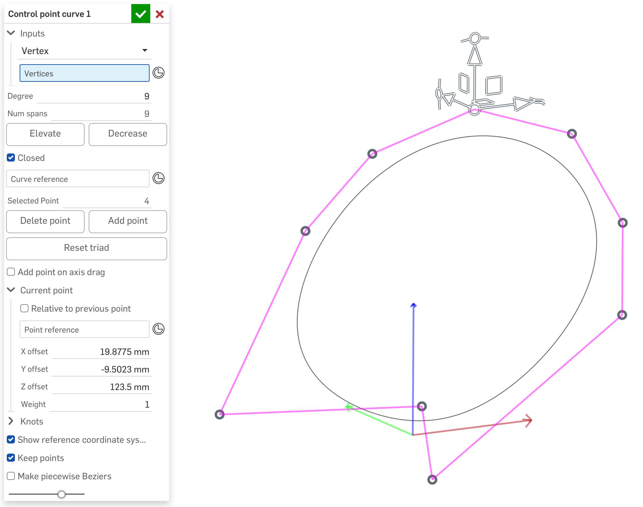
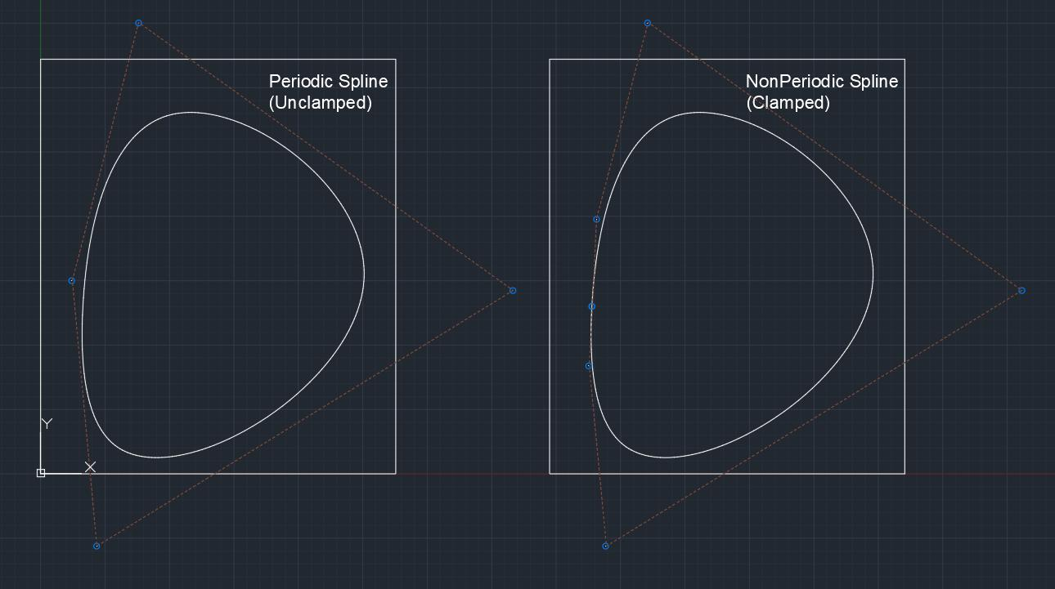
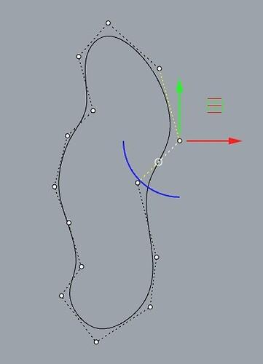
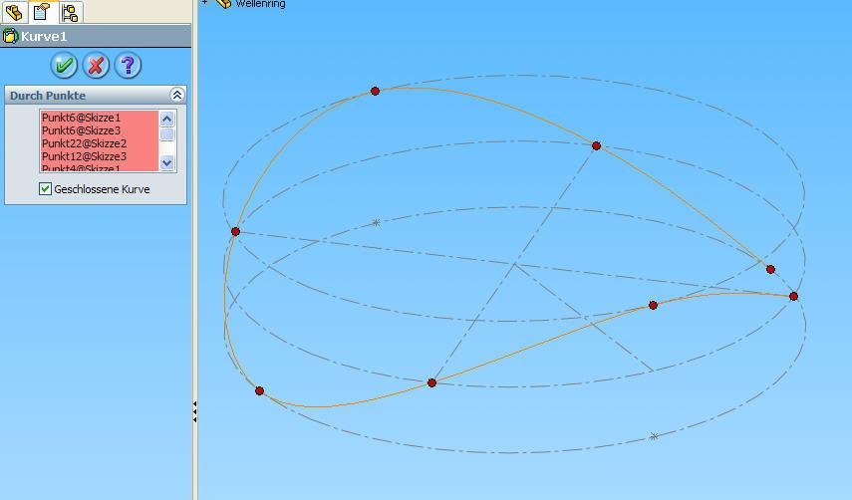
Splines are common in:
- CAD.
- Industrial design.
- Animation.
- Computer graphics.
- 3D modeling.

3. Asymmetric Freeform Closed Curves
# Source: AI Source: Provided by: [Data Path: Persons Table -> ID Column: 1, Name_En Column: Motasem Essam] -> From: [ChatGPT] on [7/25/2026]
These are freeform closed curves with no regular axis of symmetry.
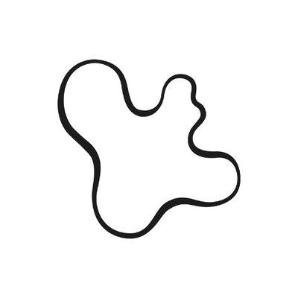
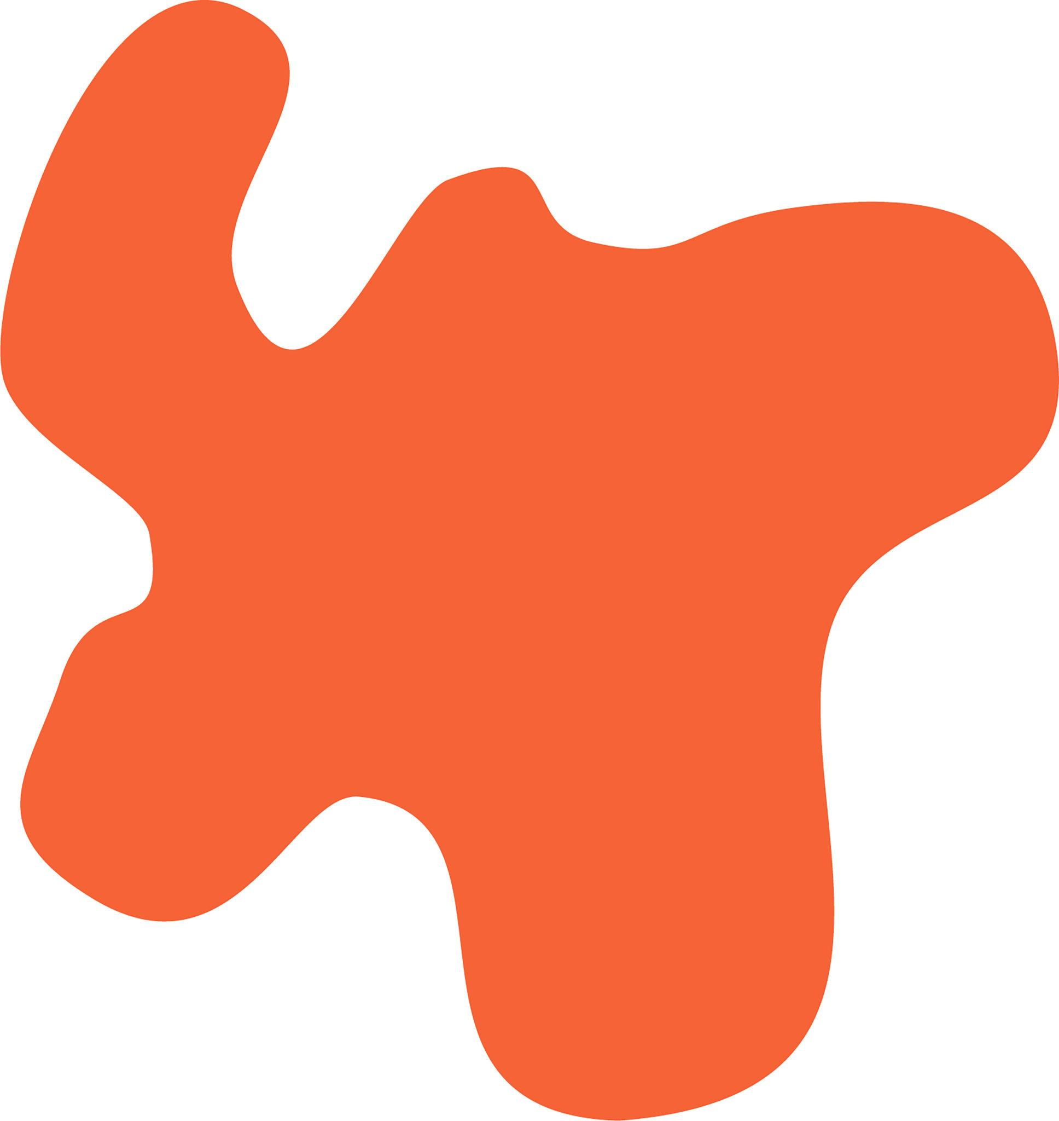
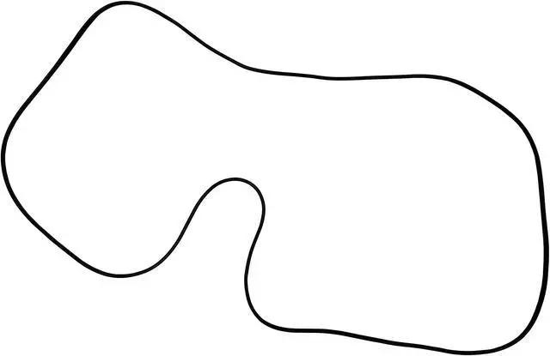

Their left and right sides may have different:
- Curvature.
- Width.
- Length.
- Shape.
$$\boxed{\text{Symmetry is not required}}$$

4. Symmetric Freeform Closed Curves
# Source: AI Source: Provided by: [Data Path: Persons Table -> ID Column: 1, Name_En Column: Motasem Essam] -> From: [ChatGPT] on [7/25/2026]
A freeform curve can still be designed with one or more axes of symmetry.
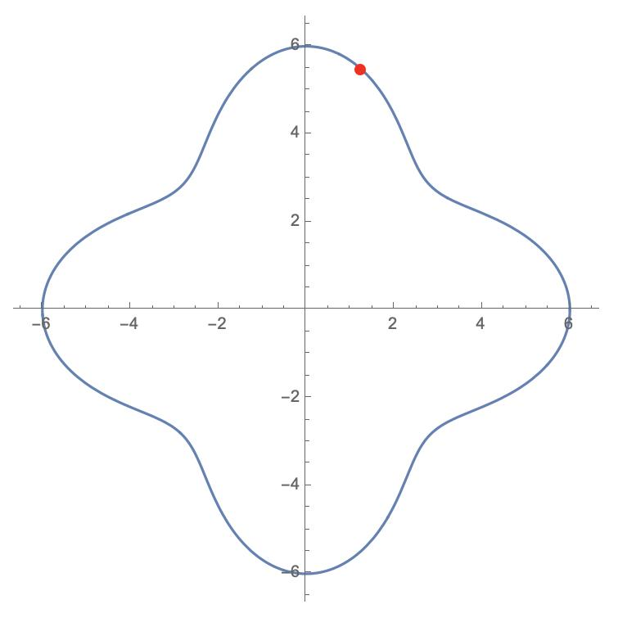
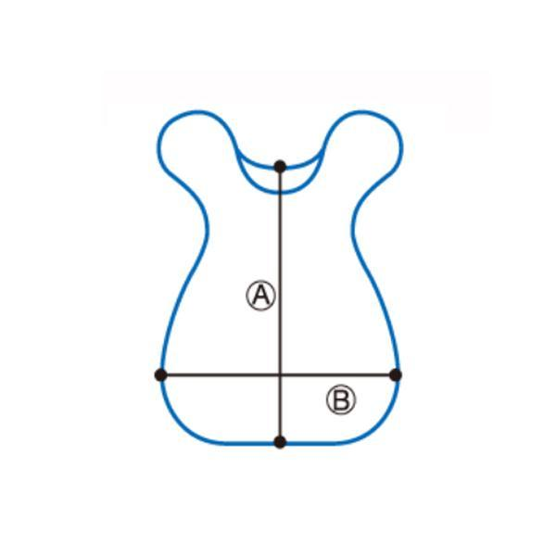
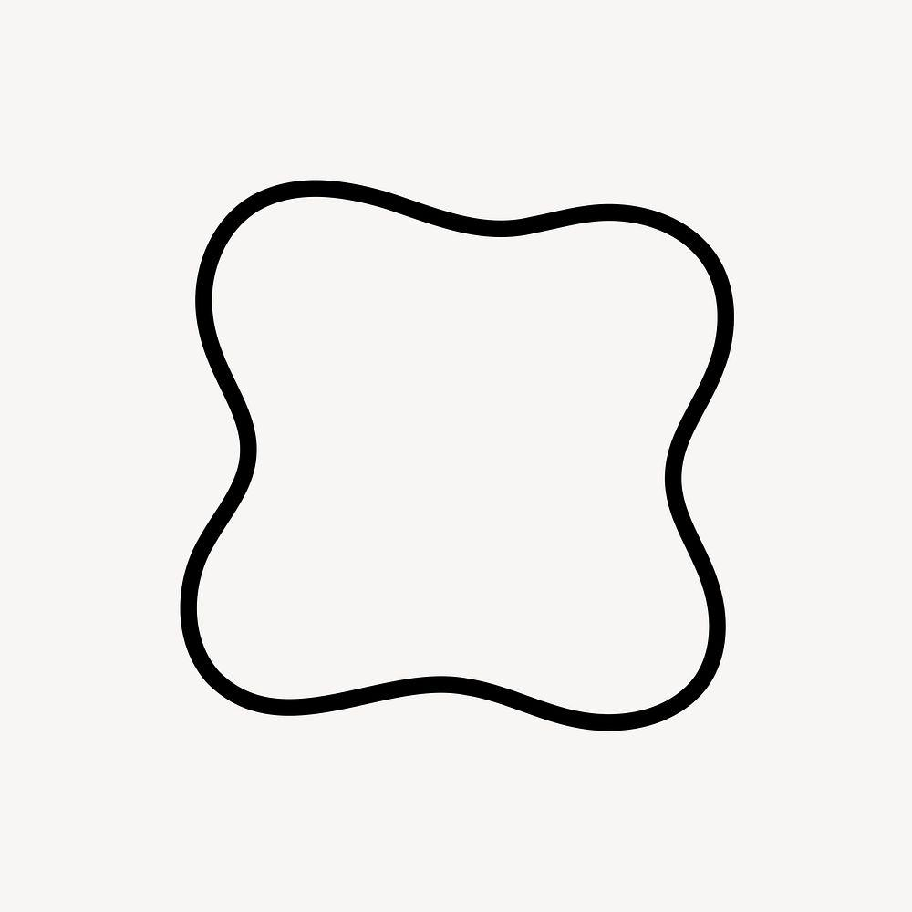
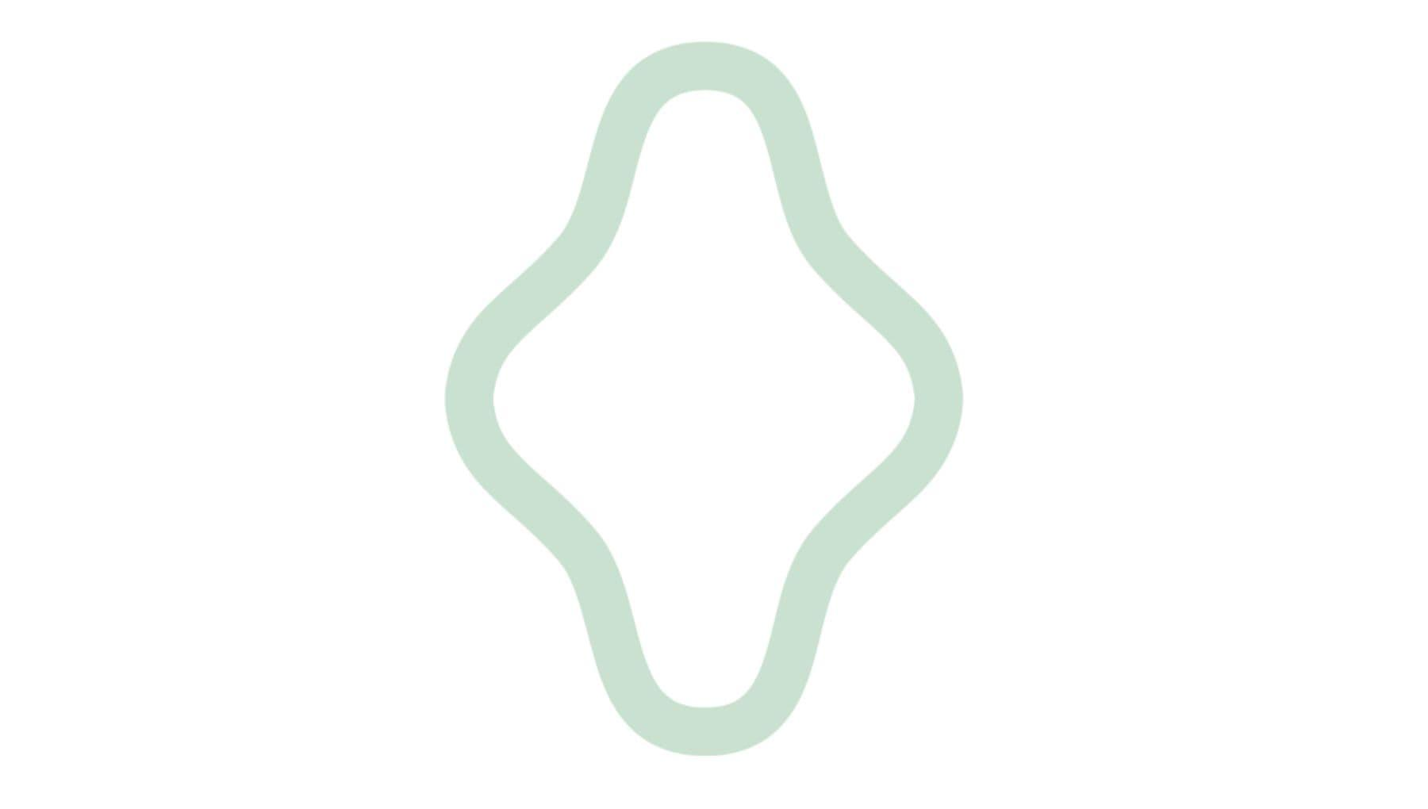
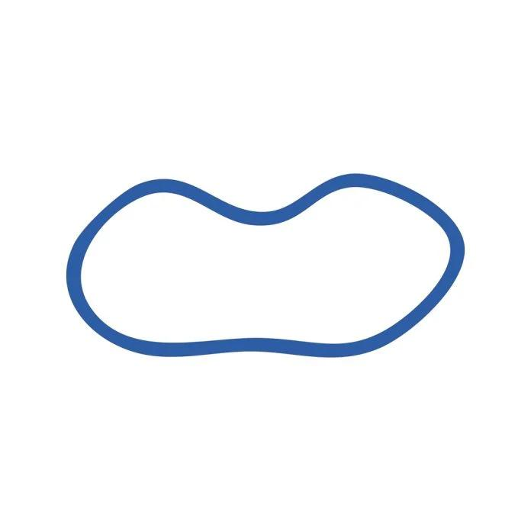
For example, the designer may construct one half and reflect it across an axis.
This produces:
$$\boxed{\text{Freeform Geometry}+\text{Symmetry}}$$

5. Wavy Freeform Closed Curves
# Source: AI Source: Provided by: [Data Path: Persons Table -> ID Column: 1, Name_En Column: Motasem Essam] -> From: [ChatGPT] on [7/25/2026]
A wavy freeform closed curve contains smooth undulations around its boundary.
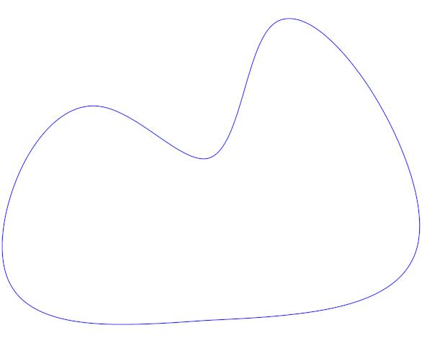
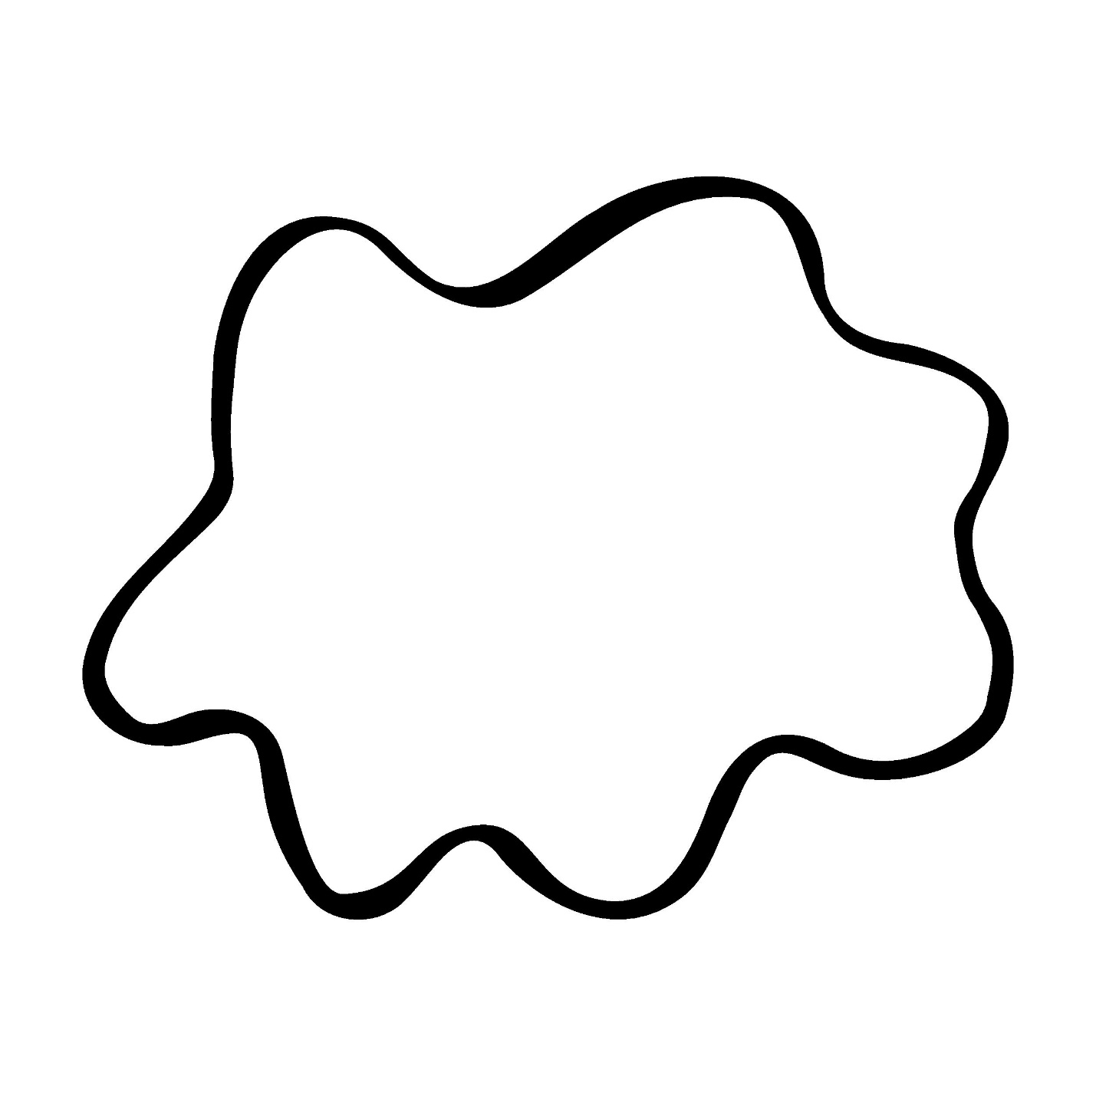
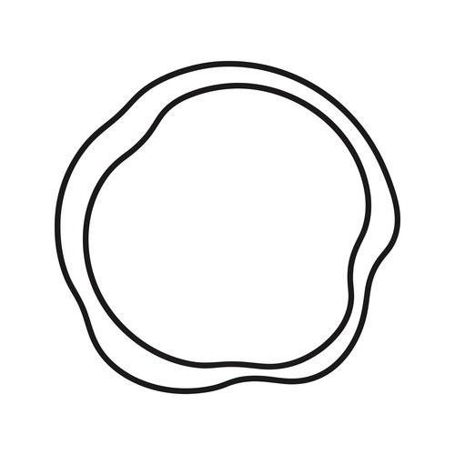
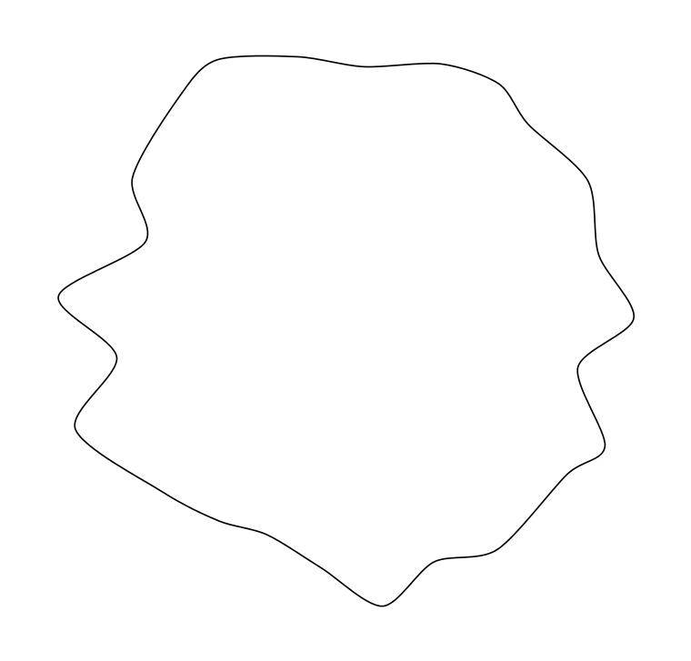
The waves can have varying:
- Amplitude.
- Frequency.
- Spacing.
- Curvature.

6. Lobed Freeform Closed Curves
# Source: AI Source: Provided by: [Data Path: Persons Table -> ID Column: 1, Name_En Column: Motasem Essam] -> From: [ChatGPT] on [7/25/2026]
A lobed freeform curve contains multiple rounded protrusions or lobes.
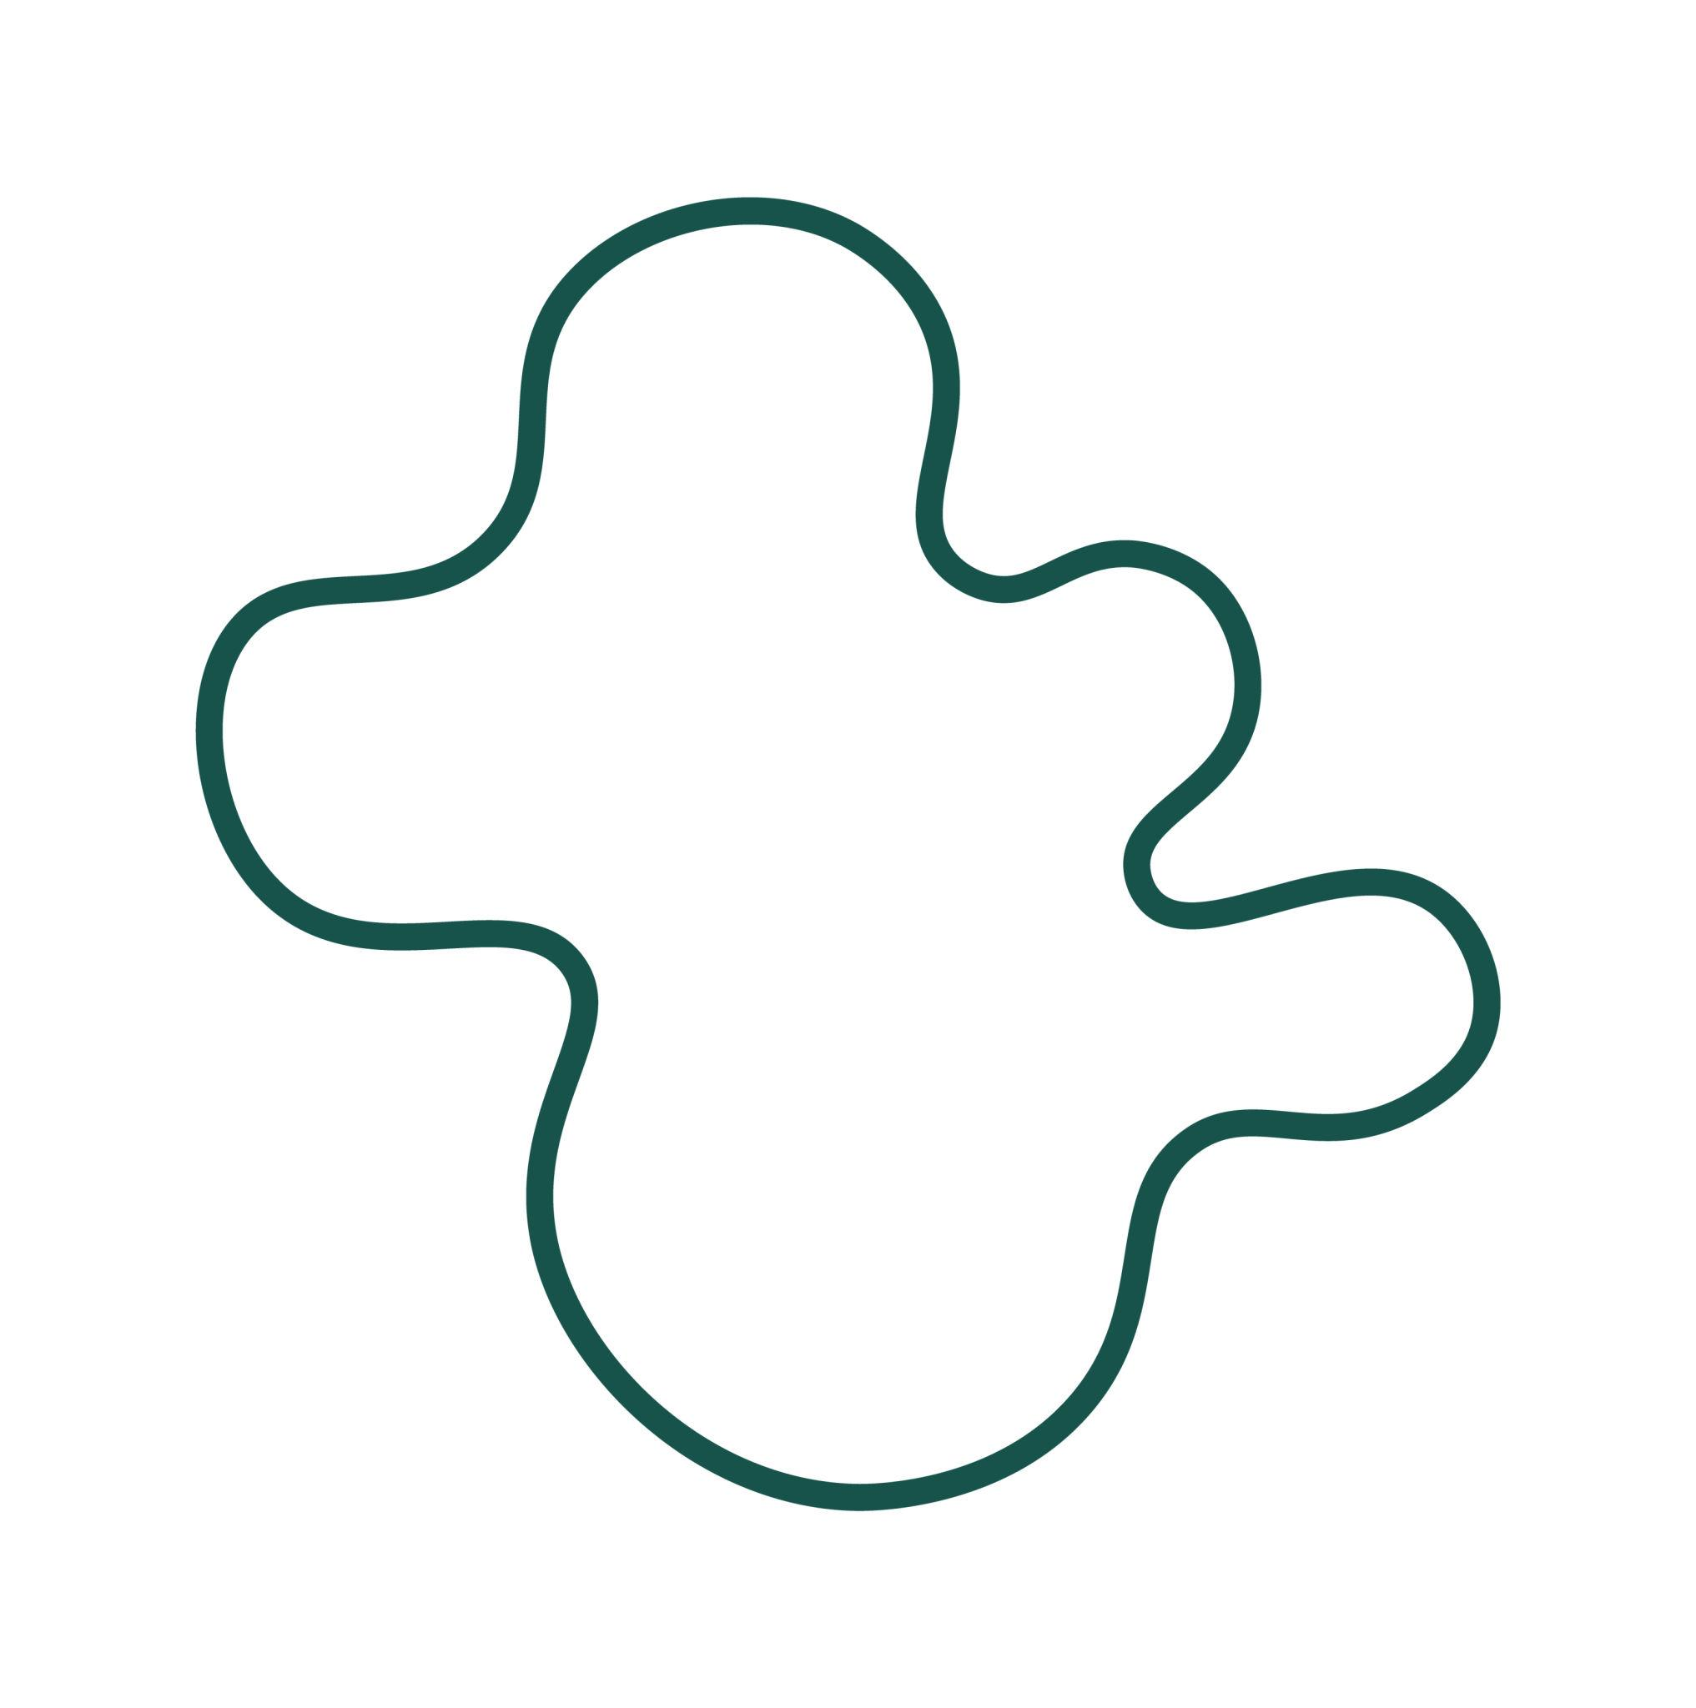
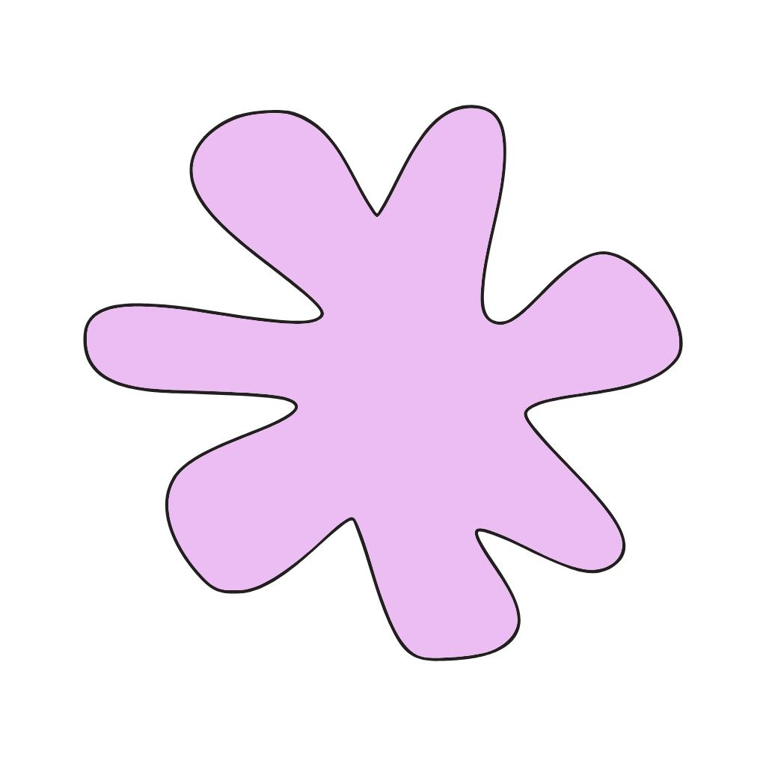

The lobes do not need to be identical.
Therefore, the shape can be:
- Symmetric.
- Partially symmetric.
- Completely asymmetric.

7. Organic-Looking Freeform Closed Curves
# Source: AI Source: Provided by: [Data Path: Persons Table -> ID Column: 1, Name_En Column: Motasem Essam] -> From: [ChatGPT] on [7/25/2026]
These are artificially created freeform curves that resemble natural or biological forms.
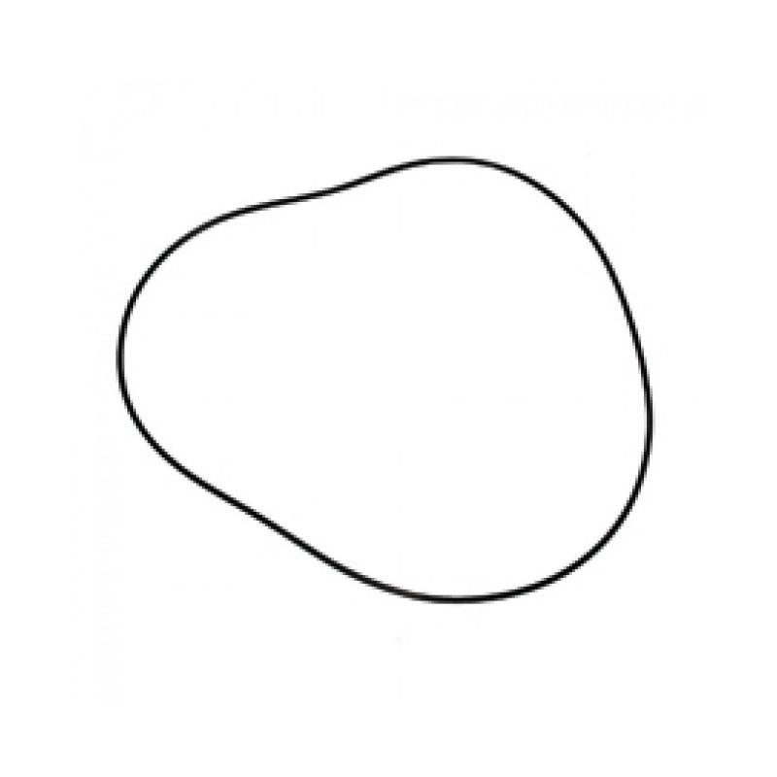
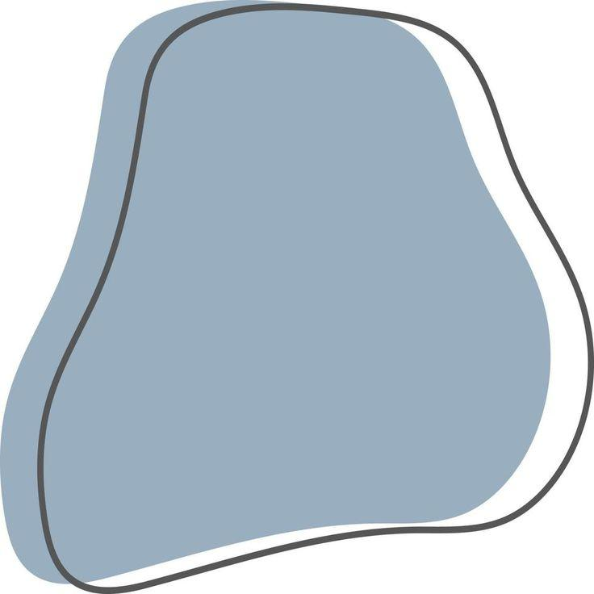
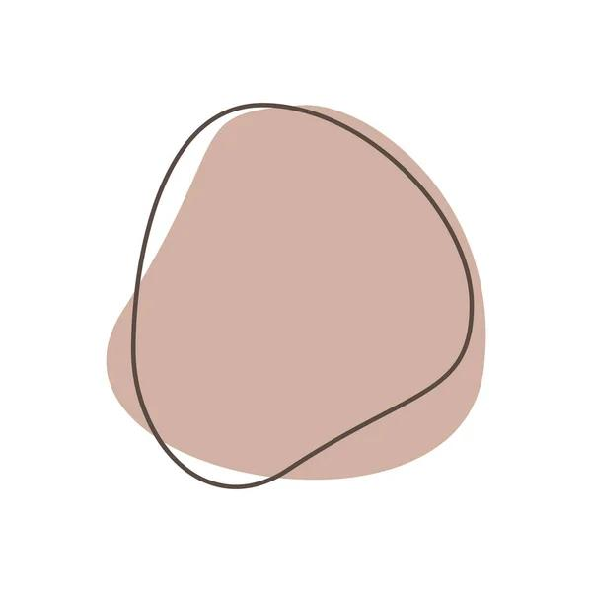
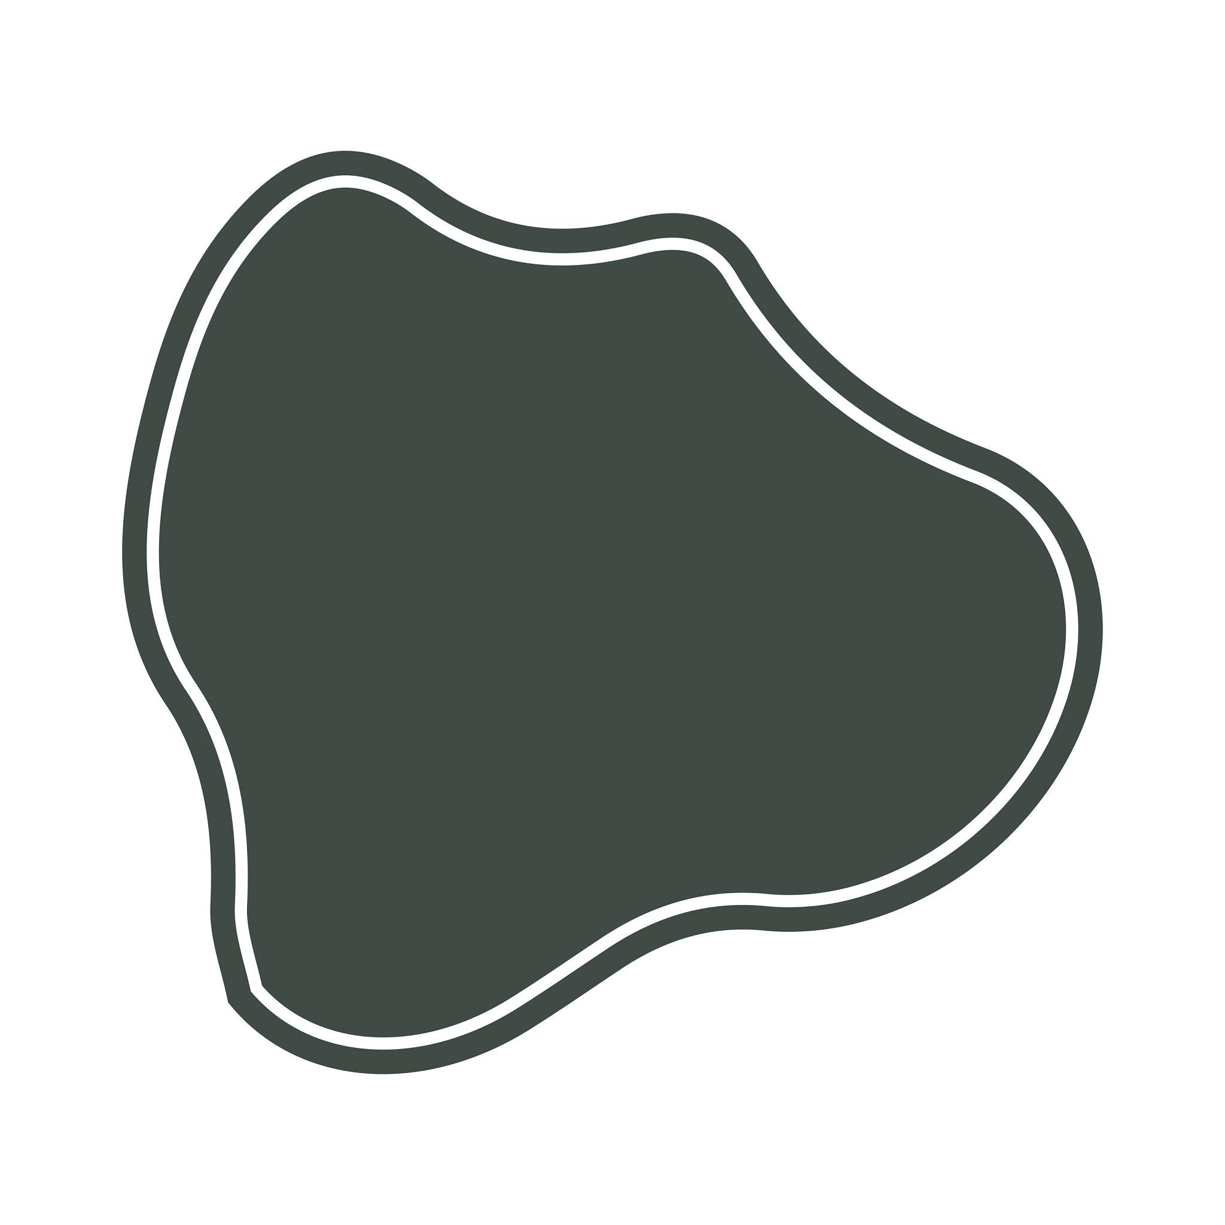
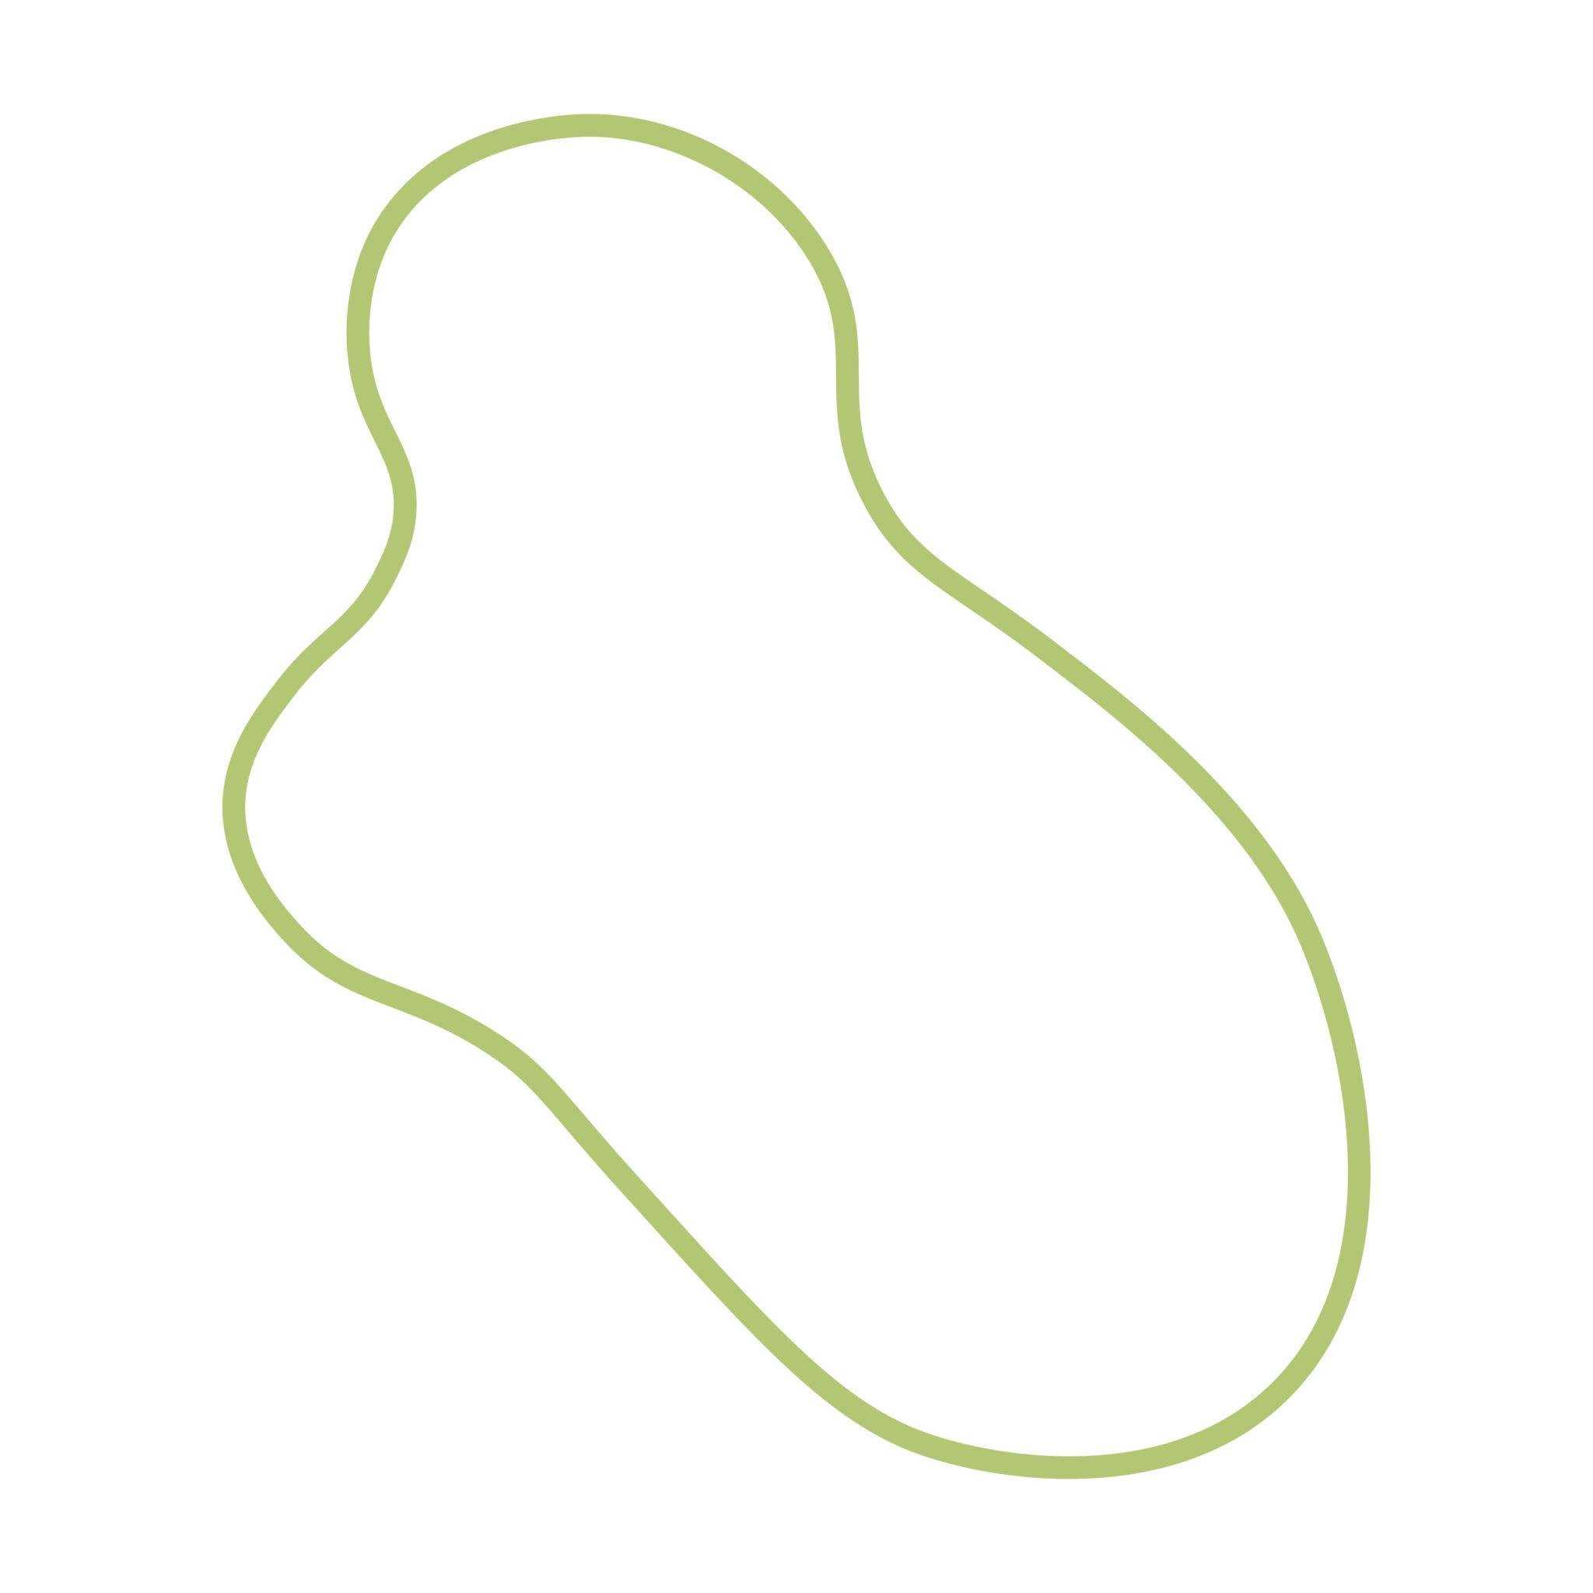
Examples may resemble:
- Leaves.
- Cells.
- Stones.
- Clouds.
- Puddles.
- Biological forms.
Important: an organic-looking freeform shape does not necessarily occur in nature. It may simply imitate natural geometry.

8. Geometric-Freeform Closed Curves
# Source: AI Source: Provided by: [Data Path: Persons Table -> ID Column: 1, Name_En Column: Motasem Essam] -> From: [ChatGPT] on [7/25/2026]
These combine an intentionally designed mathematical appearance with freely varying curvature.
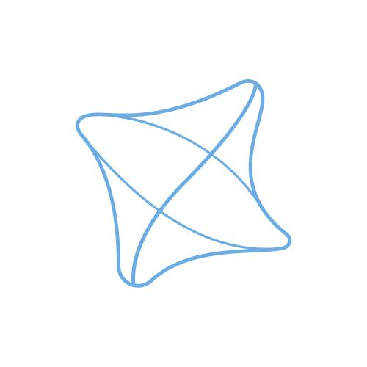
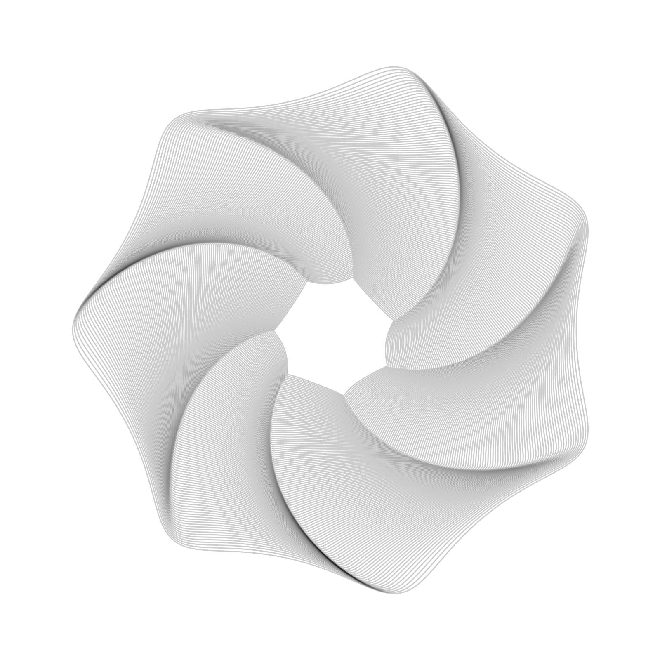
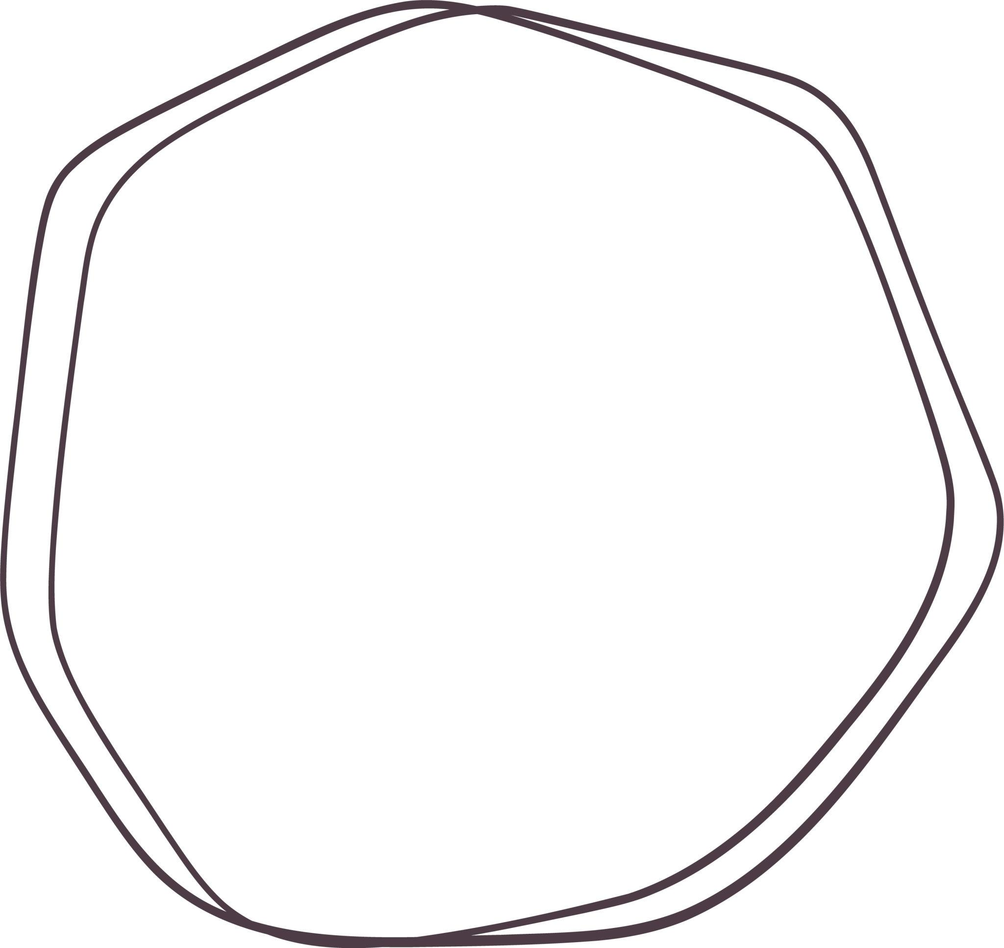
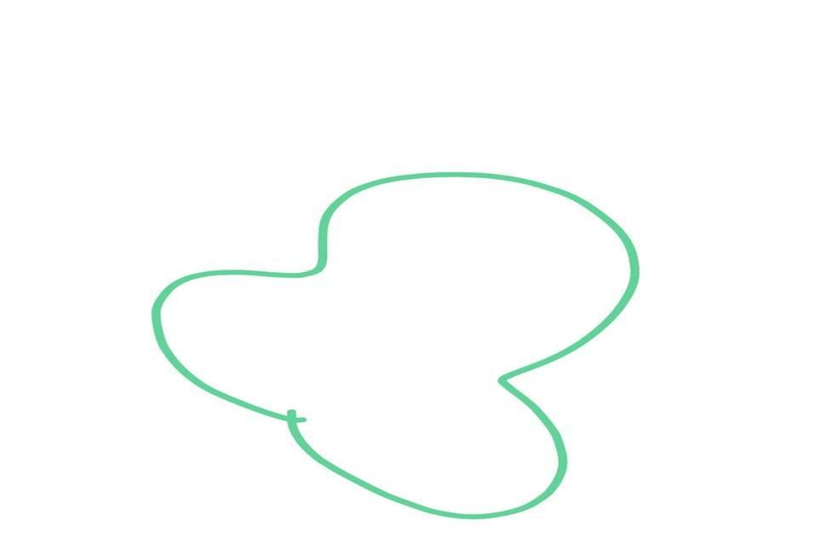
They may appear geometric without being a true:
- Circle.
- Ellipse.
- Polygon.
- Regular curve.

9. Hand-Drawn Freeform Closed Curves
# Source: AI Source: Provided by: [Data Path: Persons Table -> ID Column: 1, Name_En Column: Motasem Essam] -> From: [ChatGPT] on [7/25/2026]
These are closed curves created manually by drawing a continuous curved boundary.
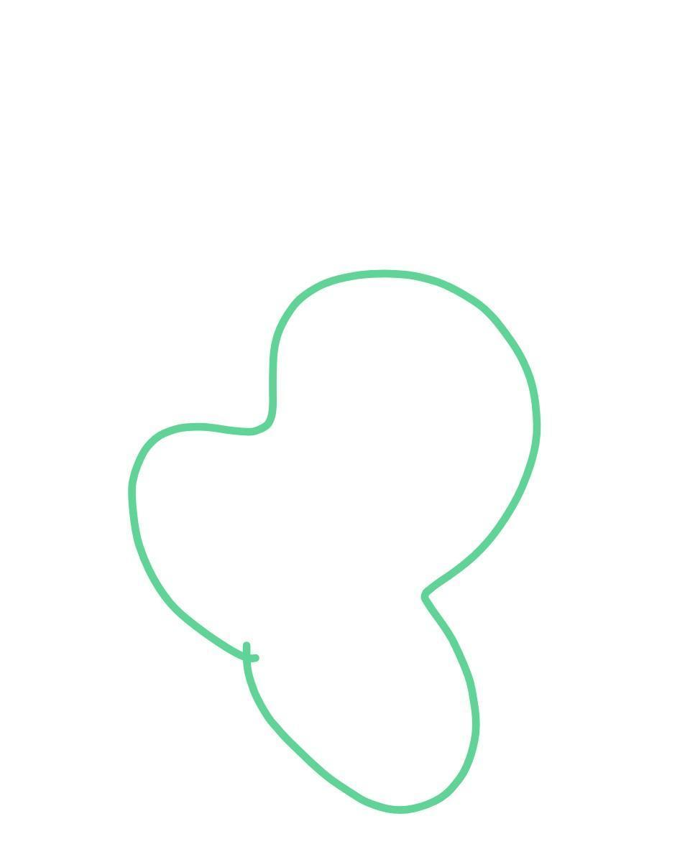
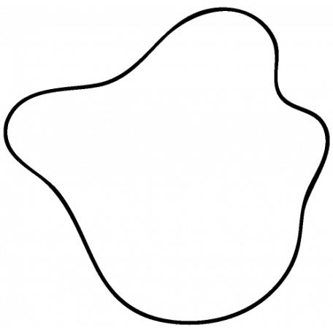
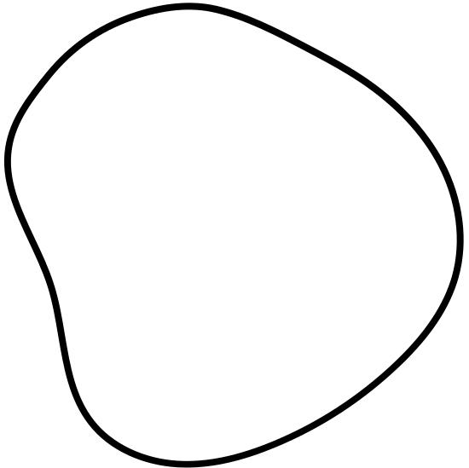
Small variations in the drawing produce irregular curvature.

10. Custom CAD Freeform Closed Curves
# Source: AI Source: Provided by: [Data Path: Persons Table -> ID Column: 1, Name_En Column: Motasem Essam] -> From: [ChatGPT] on [7/25/2026]
These are precisely controlled freeform closed curves created in CAD or modeling software.
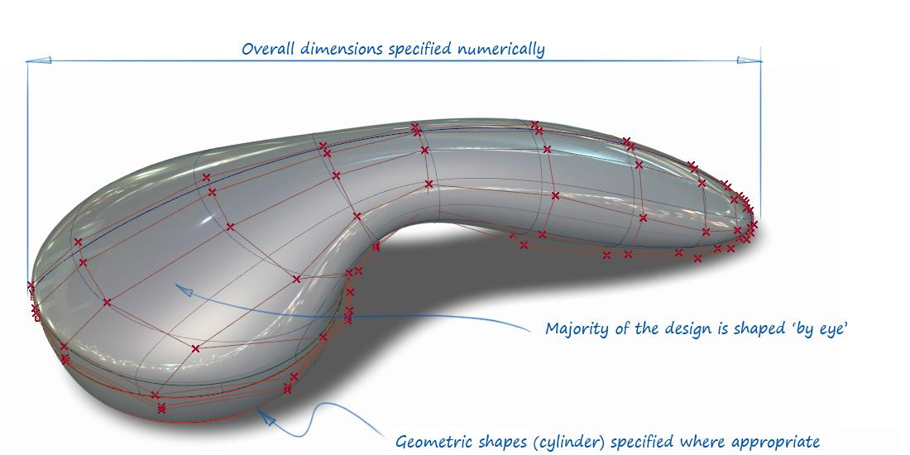
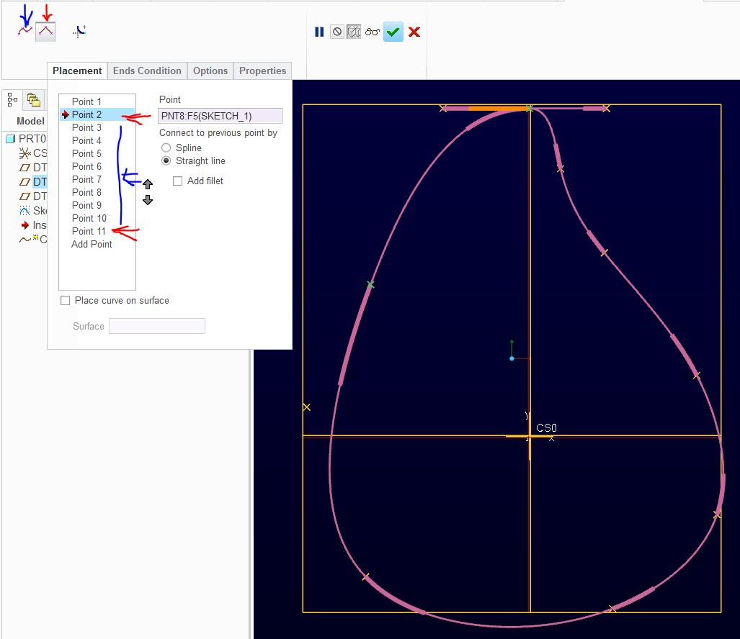
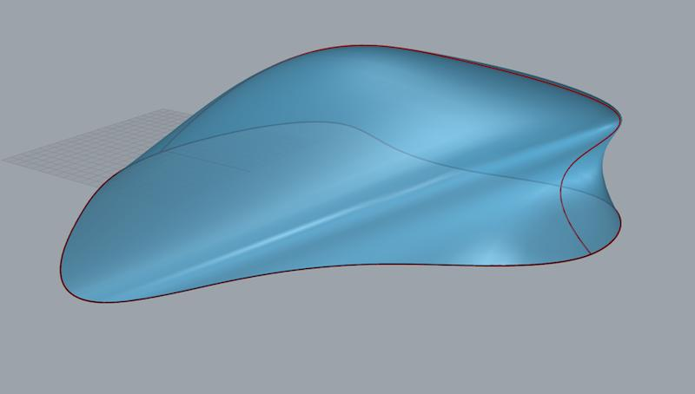
They are commonly used for:
- Product outlines.
- Automotive design.
- Industrial design.
- Aircraft components.
- Consumer products.
- Mold and tooling design.

Freeform vs. Organic Closed Curved Shapes
# Source: AI Source: Provided by: [Data Path: Persons Table -> ID Column: 1, Name_En Column: Motasem Essam] -> From: [ChatGPT] on [7/25/2026]
These categories can overlap, but their classification criteria are different.
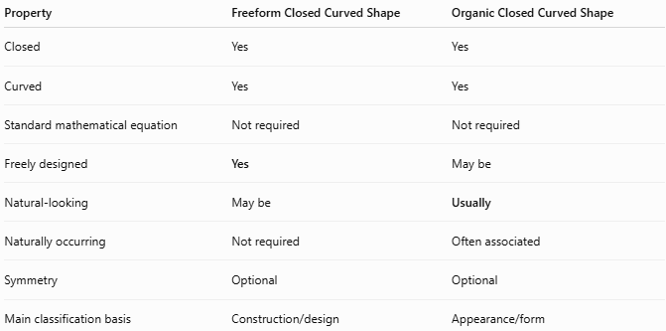
Property | Freeform Closed Curved Shape | Organic Closed Curved Shape
Closed | Yes | Yes
Curved | Yes | Yes
Standard mathematical equation | Not required | Not required
Freely designed | Yes | May be
Natural-looking | May be | Usually
Naturally occurring | Not required | Often associated
Symmetry | Optional | Optional
Main classification basis | Construction/design | Appearance/form
For example:
- A CAD-designed abstract curve → Freeform Closed Curved Shape.
- A natural-looking leaf outline → Organic Closed Curved Shape.
- A CAD shape designed to look like a leaf → both Freeform and Organic-Looking.

Freeform vs. Circular Closed Shapes
# Source: AI Source: Provided by: [Data Path: Persons Table -> ID Column: 1, Name_En Column: Motasem Essam] -> From: [ChatGPT] on [7/25/2026]
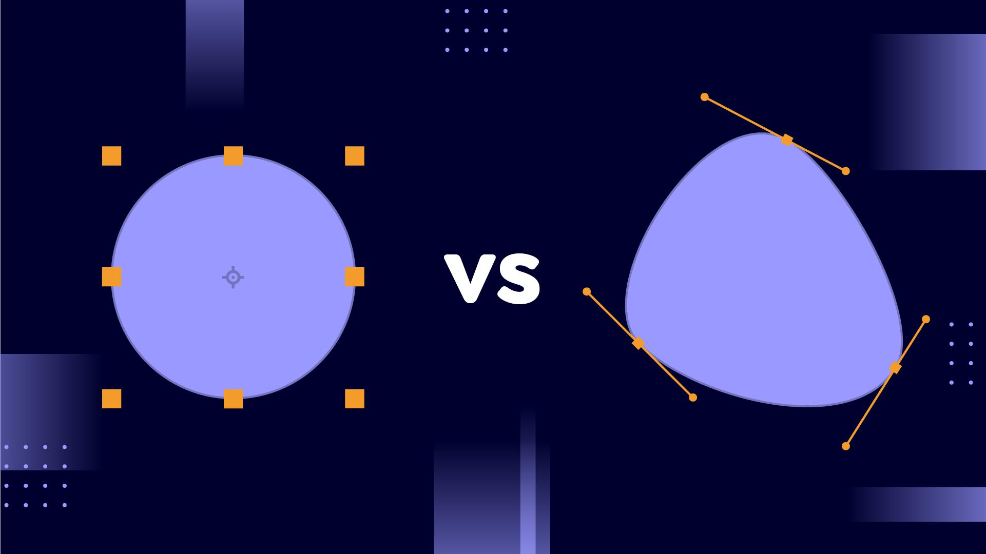
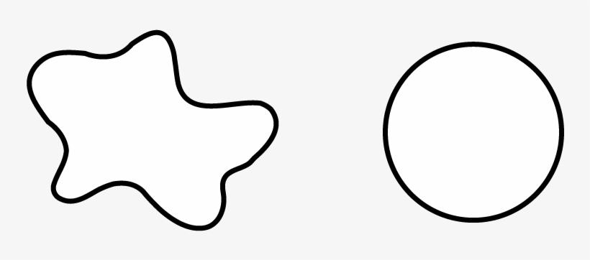
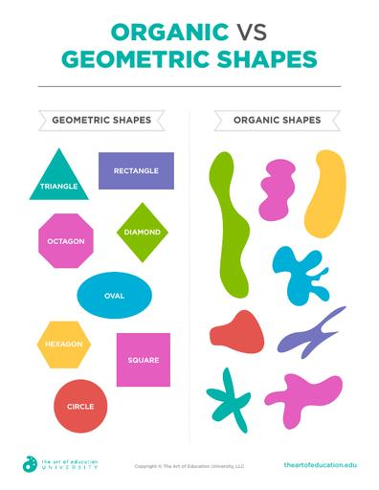
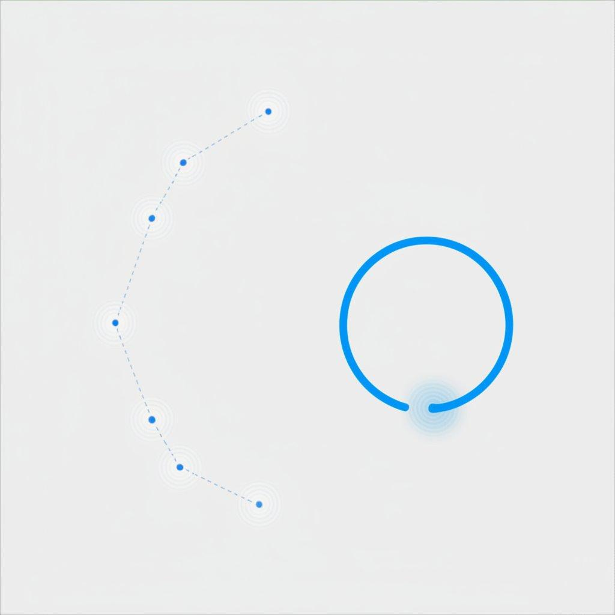
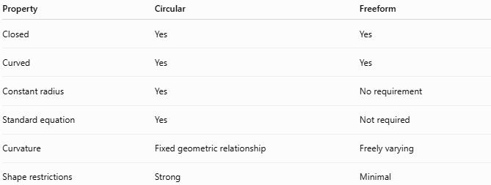
Property | Circular | Freeform
Closed | Yes | Yes
Curved | Yes | Yes
Constant radius | Yes | No requirement
Standard equation | Yes | Not required
Curvature | Fixed geometric relationship | Freely varying
Shape restrictions | Strong | Minimal
A circle has:
$$\boxed{{\left(x-h\right)}^{2}+{\left(y-k\right)}^{2}=r^{2}}$$
while a freeform curve has no requirement to satisfy the circle equation.

Freeform vs. Elliptical Closed Shapes
# Source: AI Source: Provided by: [Data Path: Persons Table -> ID Column: 1, Name_En Column: Motasem Essam] -> From: [ChatGPT] on [7/25/2026]
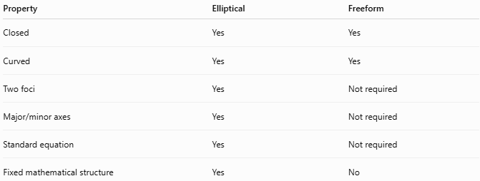
Property | Elliptical | Freeform
Closed | Yes | Yes
Curved | Yes | Yes
Two foci | Yes | Not required
Major/minor axes | Yes | Not required
Standard equation | Yes | Not required
Fixed mathematical structure | Yes | No
Thus:
$$\boxed{\text{Ellipse}=\text{Mathematically Defined}}$$
while:
$$\boxed{\text{Freeform}=\text{Design-Controlled}}$$

Boundary and Enclosed Region
# Source: AI Source: Provided by: [Data Path: Persons Table -> ID Column: 1, Name_En Column: Motasem Essam] -> From: [ChatGPT] on [7/25/2026]
Because the curve is closed:
$$P_{\text{start}}=P_{\text{end}}$$
and the boundary encloses a region:
$$\boxed{\text{Closed Freeform Boundary}→\text{Bounded Interior}}$$
Therefore, unlike an Open Freeform Curve, a closed freeform curve can define a region whose area can be measured.

Area
# Source: AI Source: Provided by: [Data Path: Persons Table -> ID Column: 1, Name_En Column: Motasem Essam] -> From: [ChatGPT] on [7/25/2026]
There is no universal simple formula for the area of a freeform closed shape.
Depending on how the curve is represented, the area can be obtained using:
- Numerical integration.
- Coordinate methods.
- Green's theorem.
- CAD area tools.
- Raster/image analysis.
- Polygon approximation.
For a parametric closed curve:
$$x=x\left(t\right), y=y\left(t\right)$$
the enclosed area can be expressed as:
$$\boxed{A=\frac{1}{2}\oint{\left(x,dy-y dx\right)}}$$

Boundary Length
# Source: AI Source: Provided by: [Data Path: Persons Table -> ID Column: 1, Name_En Column: Motasem Essam] -> From: [ChatGPT] on [7/25/2026]
The total boundary length is the curve's arc length.
For a parametric representation:
$$\boxed{L=\int_{a}^{b}{\sqrt{{\left(\frac{dx}{dt}\right)}^{2}+{\left(\frac{dy}{dt}\right)}^{2}}}dt}$$
with:
$$\left(x\left(a\right),y\left(a\right)\right)=\left(x\left(b\right),y\left(b\right)\right).$$

Key Points
# Source: AI Source: Provided by: [Data Path: Persons Table -> ID Column: 1, Name_En Column: Motasem Essam] -> From: [ChatGPT] on [7/25/2026]
A Freeform Closed Curved Shape is:
$$\boxed{\text{Closed}+\text{Curved}+\text{Freely Designed}}$$
It:
- Has a continuous closed boundary.
- Has no open endpoints.
- Encloses a bounded region.
- Has no requirement to follow a standard geometric equation.
- Can have variable curvature.
- Can be symmetric or asymmetric.
- Can be organic-looking or abstract.
- Can be created mathematically, manually, or digitally.

Conclusion
# Source: AI Source: Provided by: [Data Path: Persons Table -> ID Column: 1, Name_En Column: Motasem Essam] -> From: [ChatGPT] on [7/25/2026]
Freeform Closed Curved Shapes are closed curved forms whose boundaries are not restricted to standard geometric curves such as circles or ellipses. Their curvature can be freely controlled, making them useful for graphic design, CAD, industrial design, illustration, animation, and natural-looking forms. Important subtypes include Bézier, spline-based, asymmetric, symmetric, wavy, lobed, organic-looking, geometric-freeform, hand-drawn, and CAD freeform closed curves.

